Vision 2020 and the Malaysian Development Experience: Strengths, Achievements, and Limitations

Abstract
This paper critically examines Vision 2020, the long-term national development plan announced by Tun Dr. Mahathir Mohamad in 1991. The plan sought to transform Malaysia into a fully developed nation by 2020, not only in terms of economic prosperity but also social, cultural, political, and institutional advancement. The study highlights the strengths of Vision 2020, including its clear long-term direction, comprehensive agenda, and catalytic role in Malaysia’s modernization. It also assesses the achievements realized, particularly in economic diversification, poverty reduction, infrastructure development, and education. However, it finds that Malaysia fell short of achieving high-income nation status by 2020, and challenges such as ethnic integration, institutional weaknesses, and dependence on manufacturing and resource-based industries limited its full realization. The paper concludes that while Vision 2020 was partly successful, it remains a landmark in Malaysia’s development discourse, offering valuable lessons for subsequent national frameworks such as the Shared Prosperity Vision 2030.

1. Introduction
In 1991, Malaysia’s then Prime Minister, Tun Dr. Mahathir Mohamad, announced Vision 2020, an ambitious long-term plan designed to propel Malaysia into the ranks of fully developed nations by the year 2020. Unlike typical economic blueprints, Vision 2020 was framed around nine strategic challenges that extended beyond material prosperity to include social cohesion, political maturity, equitable economic participation, and the cultivation of a knowledge-driven society. The plan provided a clear long-term direction for national development, aligning government strategies, private sector initiatives, and social aspirations toward a shared future. Three decades later, the outcomes of Vision 2020 present a mixed picture of remarkable progress in certain domains, alongside significant shortfalls in others. This paper critically examines the strengths, achievements, and limitations of Vision 2020, assessing how far Malaysia came in realizing Mahathir’s developmental vision.

2. Literature Review
Scholarly works on Vision 2020 emphasize its dual nature as both a policy framework and a national ideology. Mahathir (1991) presented Vision 2020 as a set of nine challenges that would shape Malaysia’s transformation into a united, economically robust, and progressive society. Khoo (1995) interpreted the vision as an extension of Mahathir’s developmental state philosophy, combining economic liberalization with strong state intervention. Jomo (2004) highlighted the importance of Vision 2020 in building on the New Economic Policy’s goals of equity and national integration while adapting to globalization. Gomez and Sundaram (2017) analyzed the political economy underlying Malaysia’s growth trajectory, noting the persistence of patronage networks that complicated institutional reforms. Comparative studies with other Asian economies, particularly South Korea and Singapore, show that while Malaysia achieved significant industrialization, it struggled to break free from the middle-income trap (World Bank, 2020). Vision 2020 thus occupies a central place in Malaysian studies, symbolizing both national ambition and the challenges of structural transformation.

3. Methodology
This paper adopts a conceptual and qualitative approach, relying on secondary data sources such as government reports, World Bank statistics, and existing academic literature. The analysis is structured around three criteria: (1) economic transformation and poverty reduction, (2) social and institutional development, and (3) innovation and sustainability. By assessing outcomes against the objectives set in Vision 2020, the study evaluates both the tangible achievements and the structural limitations of Malaysia’s developmental trajectory.

4. Analysis

4.1 Strengths of Vision 2020
Vision 2020 possessed several key strengths. First, it provided a clear and unified national direction, encouraging alignment across government, business, and society. Second, it was comprehensive in scope, addressing social, cultural, and political dimensions in addition to economic growth. Third, it acted as a catalyst for modernization, inspiring projects such as the Multimedia Super Corridor, Putrajaya, and Kuala Lumpur International Airport. Fourth, it emphasized national unity through the concept of Bangsa Malaysia. Finally, it promoted global competitiveness, positioning Malaysia as an outward-looking, export-driven economy.

4.2 Achievements by 2020
Malaysia achieved notable progress under Vision 2020. The economy diversified from commodities to manufacturing and services, with GDP growth averaging above 5% during the 1990s. Poverty declined dramatically, from 17% in 1990 to less than 1% by 2016 (World Bank, 2020). Infrastructure development transformed urban centers, symbolized by landmarks such as the Petronas Twin Towers and Putrajaya. Education expanded rapidly, positioning Malaysia as a regional hub for higher learning and research. Healthcare, connectivity, and quality of life indicators also improved significantly during this period.

4.3 Limitations and Shortfalls
Despite these achievements, Vision 2020 fell short in several respects. Malaysia did not achieve high-income nation status by 2020, largely due to currency depreciation, reliance on foreign labor, and structural dependence on resource-based and manufacturing industries. The goal of Bangsa Malaysia remained elusive, with race-based politics and economic disparities persisting. Institutional weaknesses and corruption scandals, notably the 1MDB crisis, undermined governance and public trust. Furthermore, Malaysia struggled to transition into a knowledge- and innovation-driven economy, limiting its competitiveness compared to South Korea or Singapore. Environmental sustainability was also neglected, with deforestation and urban congestion becoming pressing concerns.

5. Discussion
The successes and shortcomings of Vision 2020 reflect both internal and external dynamics. Comparative analysis with Asian peers suggests that Malaysia’s developmental state approach delivered modernization but was hindered by institutional rigidity and political patronage. Crises such as the 1997 Asian Financial Crisis, the 2008 Global Financial Crisis, and the COVID-19 pandemic disrupted Malaysia’s trajectory, delaying its attainment of high-income status. The persistence of the middle-income trap illustrates structural weaknesses in innovation and productivity growth. Nevertheless, Vision 2020 provided Malaysians with a shared aspiration and inspired subsequent frameworks, including the Shared Prosperity Vision 2030, which seeks to address inclusivity and sustainability more explicitly.

6. Conclusion
Vision 2020 remains one of Malaysia’s most significant national projects. It succeeded in modernizing the economy, reducing poverty, and creating world-class infrastructure, while also providing a unifying vision of progress. However, its broader goals of achieving high-income status, fostering true national integration, and building a mature democracy were only partially realized. As Malaysia looks toward the Shared Prosperity Vision 2030, the lessons of Vision 2020—its strengths and its limitations—will remain central to understanding the challenges of national development in a rapidly changing world.

References
Gomez, E. T., & Sundaram, J. K. (2017). Malaysia’s Political Economy: Politics, Patronage and Profits. Cambridge University Press.
Jomo, K. S. (2004). The New Economic Policy and Interethnic Relations in Malaysia. United Nations Research Institute for Social Development.
Khoo, B. T. (1995). Paradoxes of Mahathirism: An Intellectual Biography of Mahathir Mohamad. Oxford University Press.
Mahathir Mohamad. (1991). Malaysia: The Way Forward (Vision 2020). Kuala Lumpur: Government of Malaysia.
World Bank. (2020). Malaysia Economic Monitor: Navigating the Pandemic. Washington, DC: World Bank.

Appendix: Figures
Figure 1. Malaysia GDP Growth Trend (1990–2020)
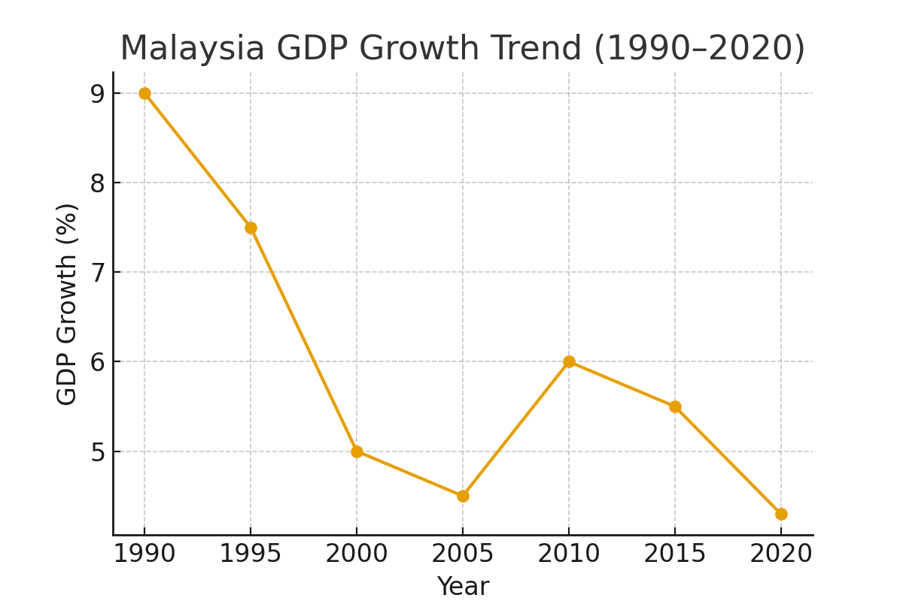
Figure 2. Malaysia Poverty Reduction (1990–2020)
